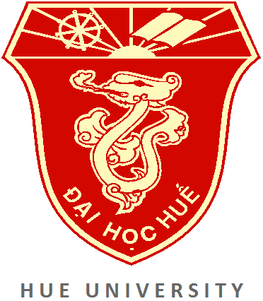 | HUE UNIVERSITY MASTER’S SCHOLARSHIPS  ACADEMIC YEAR 2015

Hue University Master’s Scholarship Scheme aims at promoting the long-standing friendship between Laos and Vietnam. The Scheme provides Lao lecturers, researchers and students with an opportunity to pursue further education and advance qualifications at Hue University’s member colleges, in these subject areas: medicine, education, foreign languages, economics, sciences, agriculture and environmental sciences. The Scheme will help develop high quality human resources for the provinces of Saravane and Xekong, as well as Lao universities, with a preference to Savanakhet University and Champasack University that have established cooperation with Hue University.
I. Awarding member institutions and types of scholarships
1. FULL SCHOLASHIP
No. | Awarding institution | Subject area | Duration | Number of scholarships
1 | Hue University (***) | All subject areas at Master’s level in Hue University | 24 months | 2
2 | College of Foreign Languages | Theory and Methodology of Teaching English; Contrastive Linguistics | 24 months | 1
3 | College of Medicine and Pharmacy | Medical Biotechnology | 24 months | 2
3 | College of Sciences | World History | 24 months | 1
(***) 02 scholarships of Hue University will be given to candidates of Sekong province (01) and Saravane province (01).

2. PARTIAL SCHOLARSHIP
No. | Awarding institution | Subject area | Duration | Number of scholarships
1 | College of Medicine and Pharmacy | 9 majors at Master’s level at the College of Medicine and Pharmacy (Medical Bio-technology is not included) | 24 months | 10
2 | College of Sciences | Management of Resources and Environment | 24 months | 1
 |  | Biotechnology | 24 months | 1
3 | College of Education | Educational Management | 24 months | 2
 |  | Theory and Methodology of Teaching Mathematics | 24 months | 1
4 | College of Economics | Business Administration, Economic Management, Political Economics, Agricultural Economics | 24 months | 1

II. Scholarship value
1. FULL SCHOLASHIP
Awarding items | Amount
Full tuition | VND 16,000,000/academic year
Living expenses | VND 18,000,000/academic year
Accommodation | VND 8,000,000/academic year
Travel cost (Lao-Viet) | VND 1,000,000/academic year
Health insurance | VND 150,000/academic year
Thesis supervision | VND 3,500,000 for the second year
Thesis defense | VND 2,500,000 for the second year
Others | VND 1,000,000/academic year
Total | VND 94,300,000 for two academic years (24 months)

2. PARTIAL SCHOLARSHIP
Awarding items | Amount
Full tuition | VND 16,000,000/academic year
Accommodation | VND 8,000,000/academic year
Total | VND 48,000,000 for two academic years (24 months)

Notes: - Accommodation will be arranged at the Dormitory of Hue University.
- Scholarships for the succeeding year will be conditional on previous year’s academic performance.
- Accommodation fee is not included in the ten partial scholarships of College of Medicine and Pharmacy.
III. Instruction language
- The official language taught is Vietnamese in all lectures.
- For Master courses of Medical Biotechnology at College of Medicine and Pharmacy language taught is only English.
IV. Selection criteria
- Applicants must hold a bachelor’s degree and transcript of a relevant or related major.
- Good Vietnamese proficiency is required (preferably applicants who have studied and graduated from Vietnam’s universities). If necessary, Hue University will form a Vietnamese examination board before official academic terms. Students who cannot meet Vietnamese requirements are required to attend a one-year Vietnamese course at Thua Thien Hue College of Education, at their own expense.
- Applicants studying in the subject area of Theory and Methodology of Teaching English, Contrastive Linguistics (College of Foreign Languages) must meet proficiency requirements for that language in accordance with the provisions of each program.
- In terms of Master courses of Medical Biotechnology at College of Medicine the applicants’ documents will be selected by Professors of Sassari University in Italy.

V. Documents
Please refer to the application form for further details.

VI. Time of application
Calls for application: There will be two calls for applications. For some training programs, there will be one call only if enrolment targets are met.
- The first call: 25 February 2015 till 25 March 2015
- The second call: 15 August 2015 till 15 September 2015
Admission process:
- The first round: 26 March 2015 till 15 April 2015
- The second round: 16 September till 10 October 2015
Academic terms: After admitted, successful applicants will be informed of commencing times and study schedules.

VII. Contact
Department of International Cooperation - HUE UNIVERSITY
03 Le Loi, Hue City, Vietnam
Tel: +84 54 3894 999; Fax: +84 54 3837 072; E-mail: ofic@hueuni.vn
http://www.hueuni.edu.vn

